Where do most Australians live and why?
Directions: Create a population density map, a climate map, and a land use map of Australia using the atlas (pg. 176-178) and answer the questions below. Be sure to include a title for each of your maps.
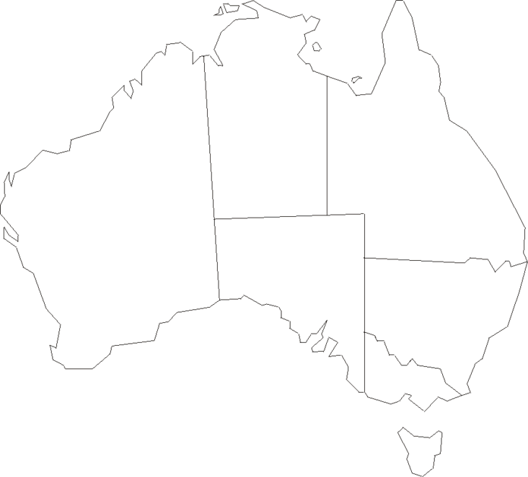

- Based on your map above, which state in Australia is the most populated?

- Explain what the climate is like in this region (your answer to #1).

- Explain what the land is like and why Australian’s would not want to live somewhere else.

- Using the physical features map of Australia on page 175, give three reasons that support your answer for #1 on where most Australian’s live and why.

