Name: Date: Class:
The Inca Empire
Directions: Use page 74 and 75 in the History Atlas to help guide you answer these identification questions.
were the Incas?
did the Inca Empire exist?
Atahualpa
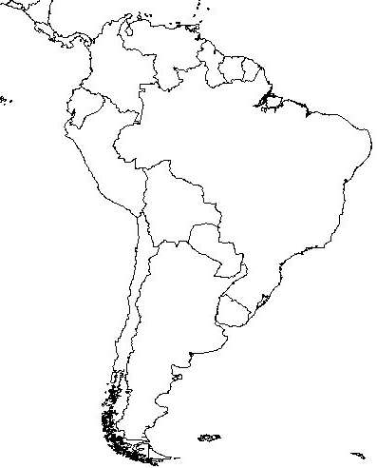

is the Inca Empire located?

Directions: Shade in the Aztec Empire when it is at its peak in 1519. Draw the Silk Road on your map as well.

are the Incas significant/important to history?

Francisco Pizarro

