Environmental Case Study: Australia’s Great Barrier Reef
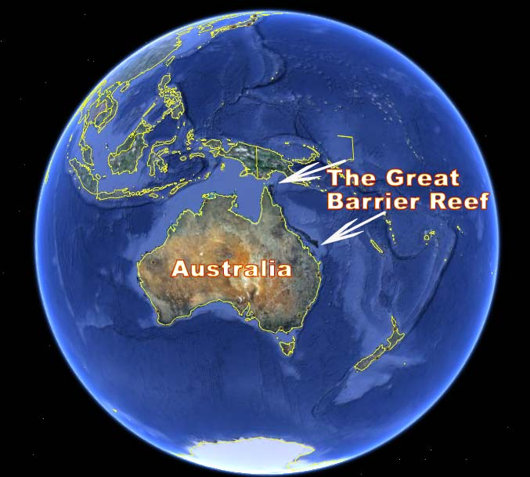
Coral reefs have been called the rainforests of the sea because of the diversity of life they support. The Great Barrier Reef provides a home for 400 different types of coral, 4,000 mollusks (like clams and sea slugs), 500 species of seaweed, 215 species of birds, 16 species of sea snakes, and more than 1,500 species of fish. Six of the world’s seven marine turtle species live in the Reef. It also serves as a breeding area for green turtles (the worlds’ largest turtle) and for humpback whales and other whale species. The Great Barrier Reef shelters some endangered species. Learn more about animals in the Great Barrier Reef by preparing a descriptive essay.
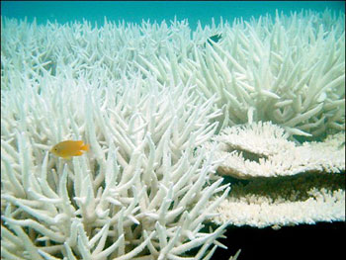
The Great Barrier Reef extends more than 1,250 miles off Australia’s northeast coast. The Reef consists of 2,900 individual reefs. It is the largest collection of reefs in the world. Its brilliantly colored coral is home to many species of plants and animals, including some endangered species. The Great Barrier Reef provides fish for people to eat and plants to make medicines. These products, along with tourism earn much money for Australia. The Reef also protects coastal towns from storms and shores from erosion. Many coral reefs around the world are in danger of being destroyed. Pollution and warm ocean temperatures cause a condition called bleaching, which sickens and kills coral. Fishing methods such as trawling take too many fish, which hurts the reefs. Tourists damage reefs by walking on them, by dragging boats over them, and in other ways. Crown-of-thorns starfish eat coral. Tropical storms, cyclones, and waves also damage reefs. Scientists, the Australian government, and conservation groups are working hard to protect the Great Barrier Reef from such dangers and to manage it wisely.
Bleaching
Corals live only in clear, unpolluted water and within a narrow range of temperatures. When the water is too polluted or too warm, the corals may become stressed. As a result, they discharge or release algae. This is dangerous because these algae give them nutrients they need. Because the algae also give them their color, the corals turn white without them. This process is called bleaching. Many corals often recover from a short period of bleaching. Longer or recurring bleaching, though, can leave them weak and more at risk for damage and disease.
In 1998 severe coral bleaching occurred in many parts of the world. It was the most widespread coral bleaching ever reported. Many researchers think the cause might have been ocean temperatures, which were the warmest on record. Some scientists believe that global warming (a worldwide increase in temperature) will produce more frequent warmer ocean temperatures. They think that these higher temperatures will cause more bleaching and destruction of reefs.
Pollution from farms, households, and industries also causes bleaching. Some authorities believe that this type of pollution poses the most serious threat to the Reef. Cattle grazing and farming erode the soil and produce polluting wastes. This material runs into coastal waters and sometimes stresses the coral.
It’s a Fact
- The first European visitor to the Reef was the British explorer named Captain James Cook, who navigated it (and ran his ship aground on it) in 1770). He began the work of charting channels and passages through the reef.
- Although coral reefs occupy less than .25 percent of the marine environment, they are home to more than 25% of all marine fish species.
- The Great Barrier Reef is home of the dugong, an endangered species closely related to the manatee. Dugongs are also called “sea cows” because they graze on meadows of sea grasses in coastal waters. An average adult dugong consumes 25 kilograms (55 pounds of sea grasses a day).

Prawn Trawling
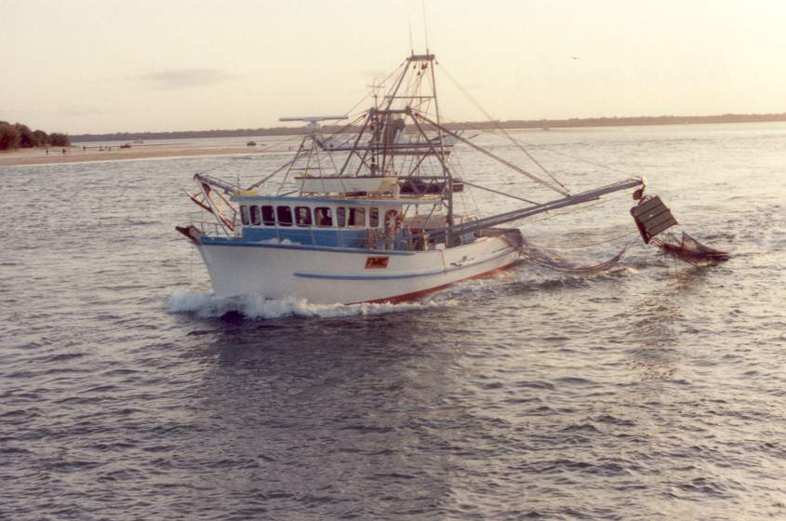
Taking too many fish from coral reefs also harms them. Prawn trawling involves dragging a net along the set floor to catch prawns (shrimplike creatures). For every pound of prawns the nets catch, they pick up 13 pounds of other marine life. These animals, which are sometimes injured, are thrown overboard and may not survive. In one study, Australian scientists found that, in just one sweep, a single prawn trawler could remove up to a quarter of a seabed life.
The Australian government has raised fines for illegal prawn trawling. It has also made equipment such as radar to catch offenders. The government is exploring other fishing methods. It now requires all trawlers in the Great Barrier Reef Marine Park area to have special devices on their nets. These devices will help keep species other than prawns out of the nets.
Starfish and Storms
Named for its cover of long, sharp spines, the crown-of-thorns starfish eats coral. It is a normal part of coral reef life. Scientists watch the Great Barrier Reef for outbreaks of too many crown-of thorns starfish. Scientists do not interfere except when the starfish threaten areas of the reef that are important to science or tourism. In those cases, the scientists inject the starfish with a drug that kills them but does not harm other plants or animals. Tropical storms, cyclones, and waves can also seriously damage coral reefs, especially if the reefs are not used to such weather.
Tourists
Each year more than a million people visit the Great Barrier Reef. They come in cruise ships, glass-bottom boats, seaplanes, and even helicopters to scuba dive and snorkel. Tourists swim over or through the reefs using snorkels or scuba diving equipment. They can damage coral reefs in many ways. These include walking on the reefs, breaking off pieces for souvenirs, dragging diving gear or boats over reefs, and dropping anchors on them. Te Great Barrier Reef Marine Park controls tourism and requires permits for certain activities.
After the widespread coral bleaching in 1998, scientists began the first thorough studies of coral reefs around the world. These studies continue today.
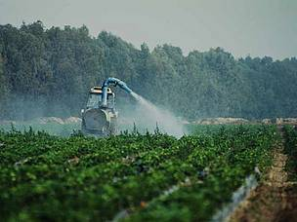
Pesticides
“Pesticides are silent killers; they can’t be seen in the reef waters, but we know they are there,” says WWF- a Reef Protection Agency in Australia (See Article 2 for more details).
Harmful concentrations of pesticides are being detected up to 60 kilometers inside the Great Barrier Reef World Heritage Area, and nearly one-third of the reef is now exposed to herbicides.
Herbicides are designed to kill weeds. But once the weeds are dead, the chemicals are being washed into rivers, estuaries and eventually coral reefs, where they can continue to harm marine plants and threaten the animals that depend upon them.
Investment- What is Australia doing to help protect the Reef?
Australia continues to invest significantly to monitor and protect the reef, and increase its resilience in the long term, while allowing sustainable use of this natural wonder. For example, the Australian Government is investing $200 million dollars over five years (2008-2013) under the Reef Rescue initiative which aims to reduce the discharge of dissolved nutrients and chemicals from agricultural lands to the Great Barrier Reef lagoon by 25 per cent, and to reduce the discharge of sediment and nutrients by 10 per cent. This includes:
- $158 million for the Water Quality Grants and Partnerships program
- $22 million for the Reef Rescue Water Quality Monitoring and reporting program
- $10 million for the Reef Rescue Research and Development program, and
- $10 million for the Reef Rescue Land and Sea Country Indigenous Partnerships program.

More about Reef Rescue
The Australian Government is also investing
- $9 million to implement the Great Barrier Reef Climate Change Action Plan
- $8 million from the Caring for our Country program to ensure that the Great Barrier Reef Marine Park Authority can continue its management and community-based Reef Guardian programs effectively
- $28.5 million under its national environmental research program for the Great Barrier Reef, Torres Strait, and Wet Tropics Rainforest, and
- $1.43 million from the Caring for our Country program to control crown-of-thorns starfish in the Great Barrier Reef Marine Park.
- Funding of $12.5 million over four years commencing in 2013-14 will also be provided to the Great Barrier Reef Foundation, which helps to protect and preserve the Reef by coordinating strategic research in such areas as reef resilience and climate change.
Environmental Case Study: Australia’s Great Barrier Reef

- List three benefits of the Great Barrier Reef site where you found them in the text.

- Explain what happens to the coral during bleaching.

- How does prawn trawling endanger coral reefs?

- Name three other ways people can damage coral reefs. Then list where you found this in the text.
A.
B.
C.
- How do Australian scientists manage crown-of-thorns starfish? Write in complete sentences.
- Based off of the article, list 4 ways that the government is trying to protect the Great Barrier Reef and explain how each of these government strategies can help the Great Barrier Reef.

Enrichment Discussion Questions (Based off of the WWF Article):
After reading this article, how do you feel about the importance of protecting the Great Barrier Reef?

How do you feel the government of Australia has done in order to promote protection of the reef? Why?

What is the purpose of the “media release”? (Inform, Persuade, Narrate, etc). Why do you think this?

What would you think WWF stands for?

Can you find any bias within this article? Identify where.

