Directions: Label the following physical features in Canada. You will need to include a title, compass, symbols, and color for your map.

- Atlantic Ocean
- Arctic Ocean
- Canadian Shield
- Great Lakes
- Gulf of Alaska
- Hudson Bay
- Pacific Ocean
- Rocky Mountains
- St. Lawrence River

Name: Class:
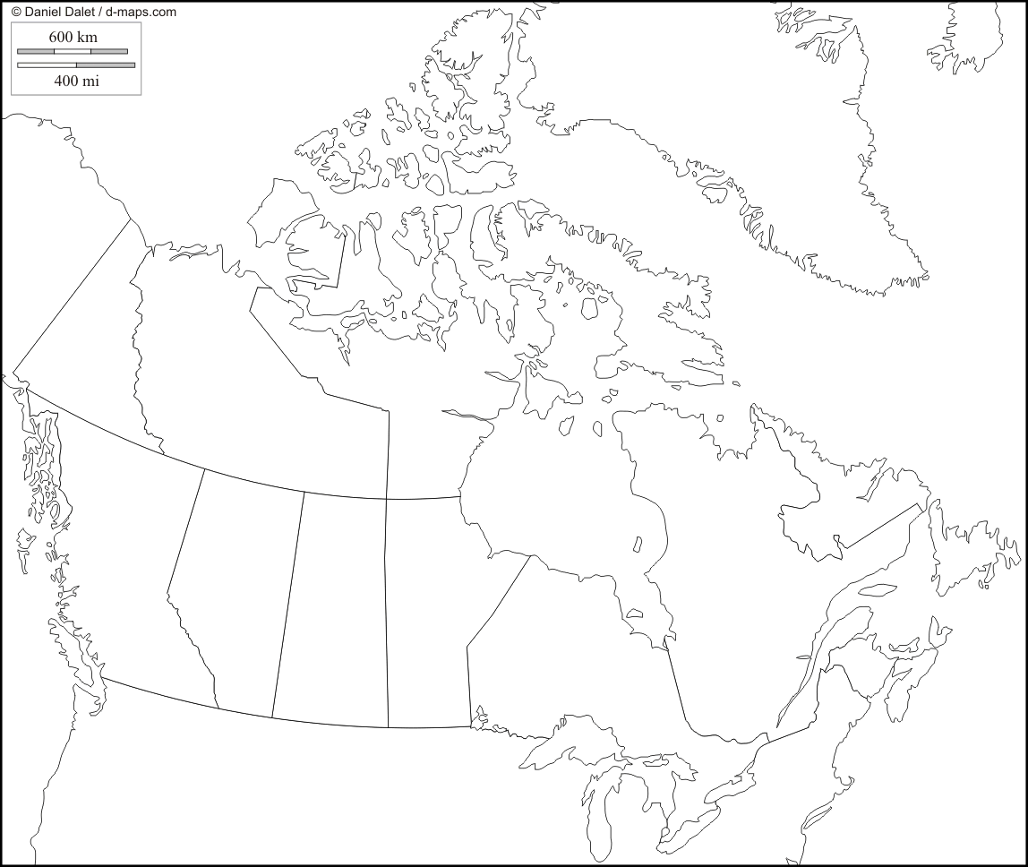
______________________________________________________________________

Directions: Label the following countries in Canada. You will need to include a title, compass, and color for your map.

- Alberta
- Manitoba
- New Brunswick
- Newfoundland and Labrador
- Nova Scotia
- Nunavut
- Northwest Territories
- Ontario
- Ottawa
- Prince Edward Island
- Quebec
- Saskatchewan
- Yukon Territory
- Greenland
- British Columbia
- United States

______________________________________________________________________
Name: Class:

