Name: Date: Class:
The Aztec Empire
Directions: Use page 74 and 75 in the History Atlas to help guide you answer these identification questions.
were the Aztecs?
did the Aztec Empire exist?
Montezuma II -

is the Aztec Empire located?
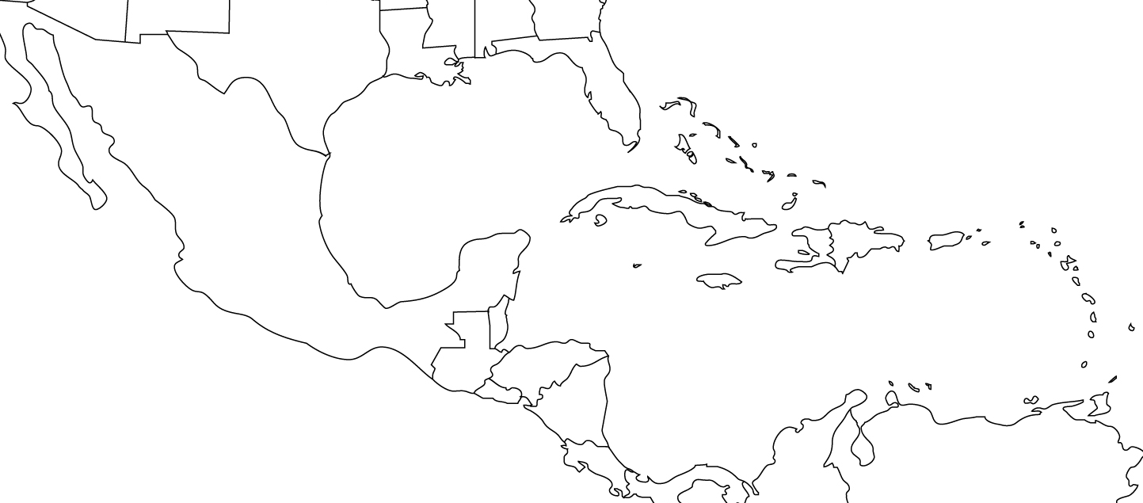

Directions: Shade in the Aztec Empire when it is at its peak in 1519. Draw the Silk Road on your map as well.

are the Aztecs significant/important to history?

Hernan Cortez -

