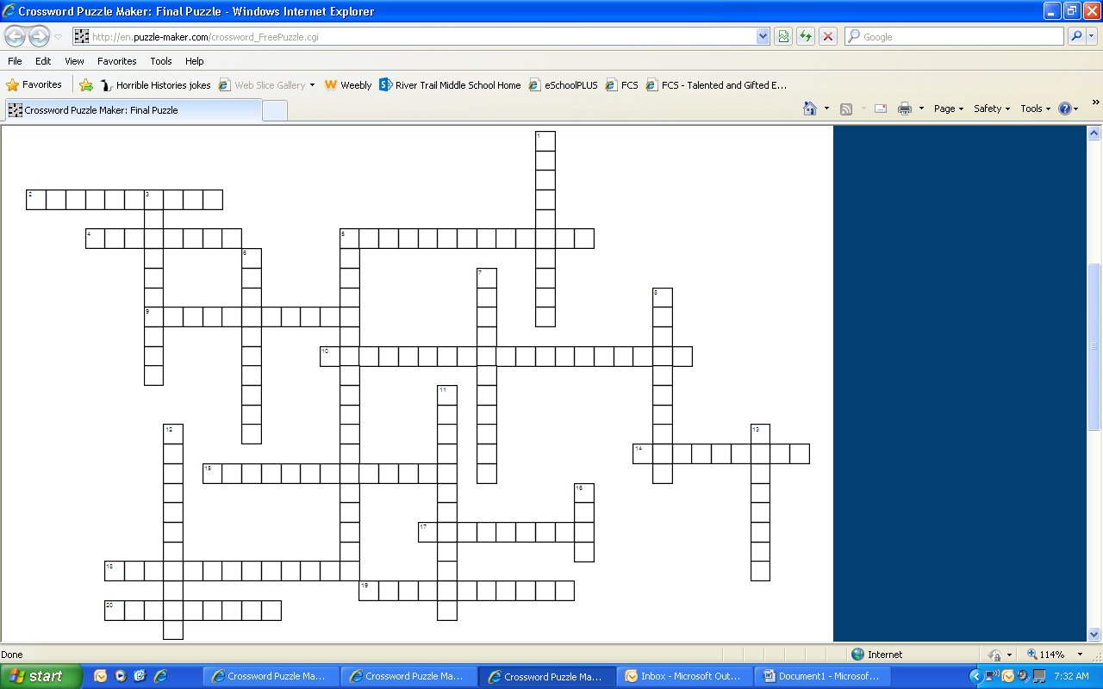
World of Wars Vocabulary Crossword
Word Bank – Central Powers, Triple Entente, Trench Warfare, Armistice, Reparations, Treaty of Versailles, Civil War, Revolution, Communism, Worldwide Depression, Appeasement, Holocaust, Genocide, Propaganda, Allied Powers, Axis Powers, Berlin Wall, Eastern Bloc, NATO, Iron Curtain, Warsaw Pact
Across  2. The Soviet Union and its satellite nations.  4. The mass murder of people because of race, religion, ethnicity, politics, or culture  5. This alliance was made up of Great Britain, France, and Russia during WWI.  9. Idea that if you meet another countries demands, you can avoid war  10. A period of low economic activity when many people lose their jobs  14. All people share equally in wealth  15. Fighting in trenches  17. Over 12 milion people were killed; 6 million of the victims were Jewish  18. This alliance was made up of Germany, Austria-Hungary, and the Ottoman Empire during WWI.  19. War Damages  20. Cease Fire | Down  1. Wall that surrounded Berlin and split East Berlin from West Berlin.  3. The persuasive attempt to influence public opinion.  5. Treaty that ended WWI and blamed Germany for the war  6. During WWII, this alliance was made up of Germany, Italy, and Japan.  7. The Eastern European countries that were headed by the Soviet Union.  8. Change in government or lifestyle  11. During WWII, this alliance was made up of Great Britain, France, and the Soviet Union.  12. Eastern and Western Europe were split during the Cold War  13. War between two groups within a country  16. North Atlantic Treaty Organization was formed by the USA as a protector from the communist states, like the Soviet Union.

